CAPSTONE PROJECT MONITORING AND MANAGEMENT
INFORMATION SYSTEM
_______________
A Capstone Project
Presented to the Faculty of
College of Computer Studies and Information System
Carlos Hilado Memorial State University
Bacolod City
_______________
In Partial Fulfillment
of the Requirement for the Degree
Bachelor of Science in Information Systems
______________
by:
John Patrick Tejoc
John Rainer Tacutan
Rheza Mae Loqueloque
Jhelian Coberos

May 2026
CHAPTER Ⅰ
INTRODUCTION
Background of the Study
Globally, higher education institutions recognize faculty guidance and structured project management as essential pillars of academic success. Research and industry practice show that dedicated project management platforms reduce administrative friction and improve on-time completion of deliverables, a benefit that carries over into academic settings where the capstone project serves as a student's culminating demonstration of competence. In computing and information technology education, the capstone course is widely regarded as a critical final milestone that validates the technical skills students have accumulated and readies them for professional practice (Li et al., 2023; Tenhunen et al., 2023). Best practices in capstone delivery include autonomy in managing project milestones, continuous progress reporting, and timely feedback from advisers (Orozco, 2025). Accreditation bodies such as ABET require evidence of sustained, mentored student work, obligating institutions to maintain reliable records of milestones, submissions, and evaluations. Consequently, cloud-based collaboration tools and dedicated thesis-management systems have become standard in universities abroad, offering centralized storage, version history, and role-based access.
Nationally, the Commission on Higher Education (CHED) emphasizes outcomes-based education and, through its policy-standard on quality assurance (CHED, 2012), requires institutions to document student outputs as part of program accreditation and annual monitoring. Philippine State Universities and Colleges must likewise demonstrate that graduates meet prescribed competency standards, including verified completion of capstone requirements. These mandates push public institutions toward digitized, transparent, and auditable academic records. Yet many still rely on fragmented tools—spreadsheet trackers, chat platforms, and shared drives—that cannot produce consolidated audit trails for milestone completion, adviser workload, or submission timelines, leaving the quality of monitoring inconsistent across departments.
Locally, the Bachelor of Science in Information Systems (BSIS) department at Carlos Hilado Memorial State University (CHMSU) has historically tracked milestones, meeting logs, and document submissions through paper forms and face-to-face check-ins. Rising enrollment gradually shifted the department toward spreadsheets, chat applications, and scattered Google Drive links for file storage. Capstone groups register informally, correspond with advisers across separate messaging apps, and upload drafts into unlinked folders. These tools provide storage but no central system, automatic version history, or timestamped records of meetings and submissions. Department heads and advisers must therefore manually reconcile meeting histories, submission timelines, and teaching workloads—processes that risk lost files, slow communication, delayed feedback, and ultimately, delayed graduation.
A gap analysis of these perspectives reveals a clear disconnect between established global practice and national quality-assurance expectations on one hand, and the tools available to the BSIS department on the other. Worldwide, centralized, version-controlled, and role-based systems are the norm for capstone supervision, and CHED standards require verifiable, consolidated records of project progression. The department, however, has no unified repository, automated milestone tracking, formal adviser-assignment mechanism, or accountable request process for meetings and submissions—creating administrative burden, weakened accountability, and compliance risk during accreditation reviews. The Capstone Project Monitoring and Management Information System (CPMMIS) was therefore developed to address this gap, providing an admin-controlled platform for formal account provisioning, adviser requests, secure project archiving, and a structured submission portal within a single, auditable system.
Statement of the Objective
General Objective
To develop a web-based management system that automates capstone project workflow for the BSIS department at Carlos Hilado Memorial State University–Fortune Towne Campus, enabling efficient milestone monitoring, transparent project auditing, and optimized faculty workload management.
Specific Objectives
Specifically, the study aims to:
1. Develop a centralized dashboard with color-coded Project Health Indicators (Green, Yellow, Red) for instant visibility into group milestones.
2. Provide an "At-a-Glance" interface for monitoring all capstone groups on a single screen.
3. Implement automated deadline alerts that notify student groups three days before a scheduled deadline.
4. Establish a secure digital repository with version control and activity logs for project document archiving.
5. Create an adviser workload overview showing faculty group allocations and assignment distribution.
6. Evaluate the system's usefulness, information quality, and interface quality as assessed by BSIS students, faculty, and administrators.

Framework of the Study
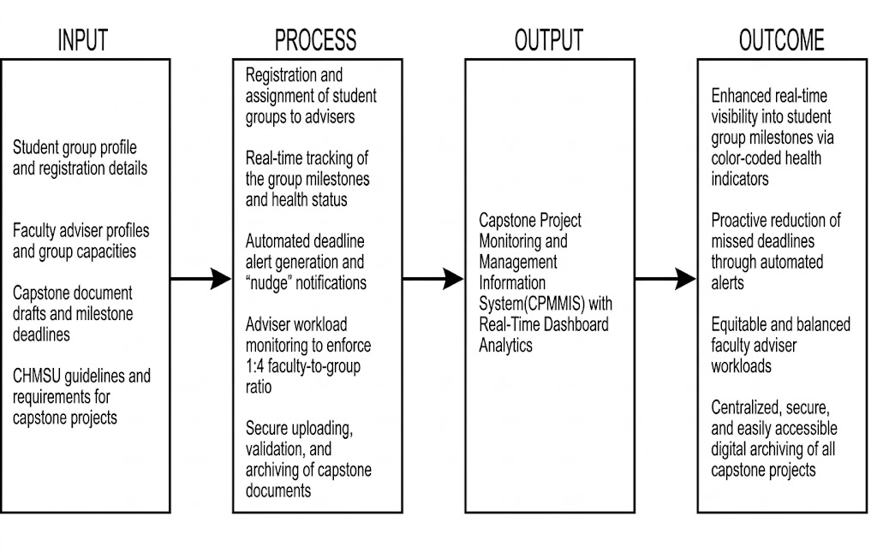 Figure 1. IPOO Framework

Scope and Limitation of the Study
Scope
This research focuses on the development and pilot deployment of a web-based Capstone Project Monitoring and Management Information System (CPMMIS) for the Bachelor of Science in Information Systems (BSIS) department at Carlos Hilado Memorial State University–Fortune Towne (CHMSU-FT). The study is conducted during the academic year 2025–2026, involving BSIS student groups, project advisers, and the department head as primary system users. The research covers the administrative workflow of capstone monitoring, including the management of user account registrations, the maintenance of digital logs for submission and meeting histories, the archiving of project documentation, and the oversight of faculty-to-group workload allocations.
Limitations
The study is restricted to the features developed within the CPMMIS and does not support integration with external institutional databases, such as the registrar's grading system or the library management portal. The system does not feature automated email or SMS dispatch for administrative approvals, meeting updates, or deadline alerts; these are communicated strictly through the internal system dashboard notifications, with system email reserved only for one-time password (OTP) verification during account access. The research relies solely on data manually provided by users within the platform; it does not capture offline consultations, verbal feedback, or external project contributions. Furthermore, the system does not include automated plagiarism detection, as this is outside the scope of administrative workflow monitoring. The study is finalized upon the initial deployment and evaluation of system quality within the pilot campus.
Significance of the Study
BSIS Department Head/Administrators. This study provides administrators with a centralized dashboard that displays the real-time status of every capstone group, enabling them to immediately identify delayed groups, monitor tracking analytics, and evaluate overall student progress without conducting manual inquiries. The system also supports data-driven academic planning and streamlines compliance reporting during institutional quality audits.
Faculty Capstone Advisers. The system gives faculty advisers a dedicated interface for managing their assigned groups, accessing a structured repository of submitted drafts, and logging weekly consultation timelines efficiently. Its workload overview also helps the department track and balance mentoring distribution across faculty members.
Capstone Student Groups. Students benefit from a transparent management workflow that keeps them constantly aware of their thesis standing through color-coded project health indicators. Automated 3-day "nudge" notifications prevent missed deadlines, while a secure digital archive protects their project files from accidental data loss or hardware failure ensuring a smoother path toward on-time graduation.
Future Developers. This study serves as a practical technical reference for developers building similar academic tracking portals or management information systems within Philippine state universities and colleges (SUCs). The documented system architecture, user role permissions, and functional module designs provide a replicable foundation for future development efforts.
Researchers. This study offers a concrete case study on how a complex, paper-dependent, and multi-tiered academic process can be digitized and optimized through local systems development. It contributes relevant insights and literature for educational technology research focusing on digital transformation and administrative efficiency in public higher education institutions.

Operational Definition of Terms
*Capstone Project Monitoring and Management Information System (CPMMIS). * A web-based platform specifically designed for the BSIS department to track student project progress, manage document submissions, and monitor faculty advisory workloads.
*Project Health Indicators. * A visual status feature within the dashboard using color-coded labelsGreen (on track/submitted), Yellow (approaching deadline/pending), and Red (overdue/at risk)—to represent the current status of student milestones.
*At-a-Glance Interface. * A centralized administrative dashboard that provides a consolidated, real-time summary of all active capstone groups, allowing the department head to view overall progress without accessing individual group files.
*Submission History. * An automated digital audit trail that records all uploaded files, file versions, and the exact timestamps of every submission made by student groups.
*Meeting History. * A digital log within the system that stores the records of adviser-student consultations, including the dates, discussion topics, and feedback provided during meetings.
*Adviser Workload Overview. * A monitoring view that displays the distribution of student groups per faculty member to promote departmental awareness of advising loads.
*Nudge Notification. * A proactive, internal system alert triggered automatically to inform student groups of impending deadlines three days before they are due.
*Digital Repository. * A secure, server-based storage area within the system dedicated to organizing, versioning, and archiving project-related documents to ensure data integrity and accessibility.
CHAPTER Ⅱ
REVIEW OF RELATED LITERATURE
In this chapter presents related literature and systems thematically arranged and considered applicable to the development of our capstone project, the Capstone Project Monitoring and Management Information System (CPMMIS)

Theme 1: Management Information Systems in Higher Education
Management Information Systems (MIS) are foundational tools originally designed for managing digital enterprises and maintaining a competitive advantage in business. According to Laudon and Laudon (2021), a Management Information System supports the managerial functions of an organization by providing timely, accurate, and relevant information for decision-making. Today, these systems are increasingly adopted by higher education institutions to drive digital transformation and improve administrative efficiency.
Ben Kasmia and M'hamed (2023) conducted a literature review on the digitalization of higher education and its impacts on management practices and institutional development. Their study found that institutions with integrated information systems experienced improved operational efficiency, better resource allocation, and enhanced institutional accountability. The transition from manual to digital systems was identified as not merely a technological shift but a strategic transformation affecting organizational culture and governance.
Singun (2025) performed a systematic literature review on the barriers to digital transformation in higher education institutions and identified that a lack of integrated systems, insufficient technical infrastructure, and limited stakeholder buy-in are among the most significant obstacles. These findings suggest that developing tailored information systems specifically for capstone project monitoring addresses a concrete need within the academic setting by bridging the gap between administrative requirements and technological capabilities.

Just as MIS streamlines workflows and reduces redundancy in corporate organizations, it serves the same critical function in academia. By understanding the core subsystems of MIS—such as transaction processing and knowledge management—universities can significantly improve their organizational performance. The transition of MIS from corporate environments to the academic sector has led to the development of specialized educational portals, including student information systems and academic monitoring platforms, which are now vital for managing student data and automating administrative workflows, directly supporting the objectives of the proposed system.
Theme 2: Capstone Project Management and Monitoring Systems
Capstone projects serve as culminating academic experiences that synthesize students' learning and demonstrate their competency in their chosen fields. As noted by Lukins (2024), the capstone project is usually the final assignment and plays a vital role in preparing students for the world of work through its practical applications and ability to hone professional knowledge and skills.
Given their scope and significance, managing capstone projects requires structured workflows that encompass proposal submissions, progress tracking, evaluation, and documentation. The transition from manual monitoring to dedicated digital platforms has become a primary focus in modern capstone project management. Sankar et al. (2023) developed a Student Management System that integrated capstone project tracking as a core module, allowing administrators to monitor student activities, manage project submissions, and maintain digital records. Their study concluded that web-based systems significantly reduce the administrative burden on faculty and provide students with transparent access to project requirements and deadlines.
Pallomina and Brosas (2025) proposed a data-driven platform that integrated skills competency assessment with academic performance to generate career pathway recommendations for students. Their system, developed using the Software Development Life Cycle methodology, was tested with 165 graduating students and demonstrated that a web-based assessment and monitoring platform could effectively support both academic advising and administrative oversight.
Fachrizal et al. (2020) developed a web-based Project Management Information System for construction projects that incorporated features for tracking work progress, managing financial data, and uploading documentation. Although situated in the construction domain, the system's architecture—featuring role-based access, milestone tracking, and real-time status updates—provides a transferable framework for academic project monitoring. The study found that digital monitoring reduced document loss and improved accountability through centralized data management.
A critical feature of modern tracking systems is the use of data visualization. Integrating dashboards and analytics into capstone evaluation allows for the real-time visualization of student progress. Secreto et al. (2025) examined the effectiveness of real-time student progress monitoring from the perspective of academic administrators. Their study found that administrators who had access to real-time progress data were better equipped to make timely interventions and data-driven decisions. The research highlighted that dashboards displaying student activity, submission statuses, and milestone achievements were essential tools for academic management.

Theme 3: Dashboard Analytics and Automated Alert Systems
Timely communication is a cornerstone of effective project management. De Vreugd et al. (2024) designed and evaluated a Learning Analytics Dashboard that supported student self-regulation of study behavior. Their study, published in the Journal of Learning Analytics, found that students who received automated visual feedback about their progress and upcoming deadlines demonstrated improved time management and task completion rates. The dashboard's notification features were identified as key drivers of behavioral change, suggesting that automated alerts can significantly enhance student engagement in capstone projects.
The visibility of progress through monitoring platforms has a direct psychological benefit. Secreto et al. (2025) recommended the integration of automated notification systems within student progress monitoring platforms, noting that real-time alerts for approaching deadlines and incomplete submissions helped reduce the incidence of late or missing deliverables. These findings reinforce the importance of incorporating automated notification mechanisms to ensure timely compliance with academic milestones.
As these tracking systems evolve, they are beginning to incorporate proactive features to prevent academic delays. By utilizing monitoring data, systems can help identify students at risk of missing deadlines and address concerns before they escalate. This aligns directly with the automated deadline alerts and notification features built into the proposed Capstone Project Monitoring and Management Information System.

Theme 4: Web-Based Technologies and System Architecture
Security and data privacy are essential considerations in multi-user information systems. Pressman and Maxim (2020) emphasized that role-based access control (RBAC) is a widely adopted approach for managing user permissions in software systems, allowing different user types—such as administrators, faculty, and students—to access only the data and functions relevant to their roles. In academic systems, RBAC ensures that sensitive student information is protected while still enabling transparency and collaboration among authorized users.
Ben Kasmia and M'hamed (2023) noted that digital transformation in higher education requires careful attention to data governance, including the implementation of access controls that prevent unauthorized data modification while supporting the information needs of various stakeholders. Their findings align with the design of the proposed system, which distinguishes between student, adviser, panelist, and administrator roles.
Several existing systems demonstrate the viability of web-based platforms for academic management. SourceCodester (2021) published an Online Thesis Archiving System built with PHP and MySQL that allows students to submit capstone projects and administrators to manage and publish accepted works. The system features role-based modules for management and students, including submission approval workflows and public access to archived projects. Its architecture—built on the LAMP stack with Bootstrap and AdminLTE—closely mirrors the technology choices in the proposed system.

Theme 5: Related Systems
Sankar et al. (2023) implemented their Student Management System using web technologies to digitize paper-based record-keeping. The system provided a secure online interface for managing student data, academic achievements, and project records, demonstrating that web-based architectures offer scalability and accessibility advantages over traditional manual systems.
Perante et al. (2024) designed and developed a Thesis and Capstone Project Manuscript Archiving Management System for Eastern Visayas State University Ormoc Campus, a project that shares both institutional context and functional requirements with the present study. Their system focused on the archival and retrieval of completed manuscripts using a combination of Agile concepts and Rapid Application Development (RAD). The study found that existing archival systems lacked essential features to effectively manage thesis and capstone project manuscripts, supporting the need for more comprehensive digital solutions.
While these related systems address individual aspects of capstone project management—such as archival, submission, or assessment—they do not fully integrate real-time milestone tracking, automated deadline alerts, role-based dashboards, and digital document management in a single platform. The proposed Capstone Project Monitoring and Management Information System (CPMMIS) aims to fill this gap by combining these features into one cohesive system tailored to the needs of Carlos Hilado Memorial State University.

Related Systems
Table 1. Comparison of the Related Systems
FEATURE

Features | Web-based Student Project Archiving System | Automated Thesis Workflow and Tracking Portal | Mentorship Monitoring System for Higher Education | Document Management System for Academic Submissions | Capstone Project Monitoring and Management Information System
Web-based Platform
Account & Role Management
Milestone Tracking & Dashboards
Automated 3-Days Deadline Alerts
Digital Capstone Archiving
Web-based  Real-Time Chat |  |  |  |  | ~ (admin-adviser only, no student)
Adviser Workload Tracker |  |  |  |  | ~ (basic count chart, no load balancing)

Synthesis
The reviewed literature demonstrates that Management Information Systems have been widely adopted in higher education to improve administrative efficiency, student monitoring, and data-driven decision-making. Studies by Laudon and Laudon (2021), Ben Kasmia and M'hamed (2023), and Singun (2025) establish the theoretical and practical foundations for implementing MIS in academic settings. Research on capstone project management by Sankar et al. (2023), Pallomina and Brosas (2025), and Perante et al. (2024) validates the need for specialized systems that address the unique workflows associated with culminating student projects.

Furthermore, the literature on progress monitoring (Secreto et al., 2025; Fachrizal et al., 2020), learning analytics dashboards (De Vreugd et al., 2024), and role-based access control (Pressman & Maxim, 2020) provides design guidance for the key features of the proposed system. However, no existing system fully integrates real-time milestone tracking, automated deadline alerts, role-based dashboards, and digital document management in a single platform tailored to capstone project monitoring. This gap supports the development of the proposed Capstone Project Monitoring and Management Information System for Carlos Hilado Memorial State University.

CHAPTER Ⅲ
METHODOLOGY
This chapter presents the development methodology, feasibility assessments, system architecture and design, and evaluation procedures utilized in developing the Capstone Project Monitoring and Management Information System (CPMMIS) for the Bachelor of Science in Information Systems (BSIS) Department of Carlos Hilado Memorial State University–Fortune Towne (CHMSU-FT).
The researchers adopted a developmental-evaluative approach. The developmental aspect involved the actual construction of the system, from requirements gathering to deployment, while the evaluative aspect assessed the finished product against ISO/IEC 25010 quality criteria through User Acceptance Testing (UAT) with the intended end-users.
System Development Model
The researchers utilized the Agile Software Development Life Cycle (SDLC) as the primary framework for developing the CPMMIS. Agile, as defined by Pressman and Maxim (2020), is an iterative approach that emphasizes flexibility, continuous collaboration, and the delivery of functional software in short, manageable cycles called sprints.
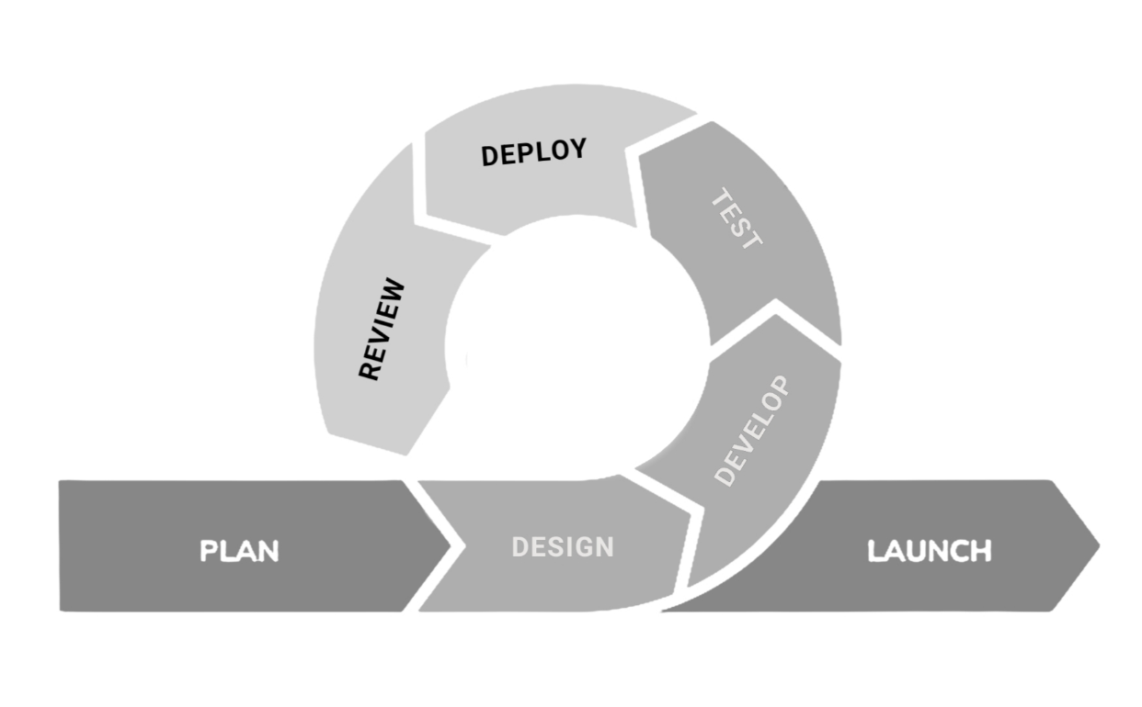
Agile was selected because the system's interconnected modular features, such as the project health dashboard, the automated three-day "nudge" notifications, and the admin-adviser messaging system, required continuous testing and ongoing refinement based on user feedback. Furthermore, the Agile methodology allowed the system's design and functionality to adapt dynamically to the practical administrative needs of the BSIS Department Head, project advisers, and student groups throughout the entire development phase.
Figure 2. Agile Development Model
Plan
The Plan phase focused on recognizing the operational bottlenecks experienced by the CHMSU-FT BSIS Department Head, faculty advisers, and student groups in manually monitoring capstone projects. To establish a clear direction, the researchers conducted data gathering and process analysis to finalize the study's objectives, scope, limitations, and significance. A comprehensive review of related literature on educational management information systems was then performed. Before implementation proceeded, a feasibility assessment evaluated the technical, operational, schedule, and economic viability of the project, while a Gantt chart and Work Breakdown Structure were created to keep the development timeline strictly on track.
Design
Utilizing the data gathered from stakeholder consultations, the team formulated the structural blueprint of the application. This involved mapping the database schema through an Entity-Relationship Diagram, establishing data pathways using a Data Flow Diagram, and compiling a Data Dictionary. To ensure a highly visible user experience, UI wireframes and interactive mockups were crafted, placing special emphasis on the centralized "At-a-Glance" administrative dashboard and the color-coded project health indicators.
Develop
The actual construction of the software took place during this stage, leveraging PHP for server-side processing and MySQL for robust relational database management. To guarantee a modern, responsive, and accessible interface, the front end was engineered using HTML, JavaScript, and the Tailwind CSS framework. The coding process was divided into targeted workstreams to handle the secure digital archiving module, the admin-adviser messaging system, and the automated three-day "nudge" deadline scripts. By strictly following an iterative sprint approach, individual features were continuously coded, reviewed, and enhanced in rapid succession.
Test
To guarantee system integrity, comprehensive quality assurance protocols were executed. Every newly built module underwent rigorous unit and integration testing to ensure that components such as the adviser workload overview functioned flawlessly both independently and as a unified system. Following this, User Acceptance Testing was facilitated with selected BSIS administrators, project advisers, and students. Their evaluation was heavily based on the ISO/IEC 25010 software quality standards, specifically measuring functional suitability, reliability, usability, performance efficiency, and maintainability. Any defects discovered were strictly documented and corrected prior to moving forward.
Deploy
The finalized system was deployed to the target environment for pilot use by the intended end-users within the CHMSU-FT BSIS Department.
Review
During the pilot implementation, continuous monitoring was conducted to evaluate user satisfaction and system performance. The researchers actively gathered feedback from the Department Head, advisers, and students to confirm that the software strictly complied with the requirements established in the planning phase. Any operational issues or necessary workflow adjustments identified by the users were documented and addressed immediately.
Launch
Once all necessary refinements had been applied, the CPMMIS was officially turned over to the CHMSU-FT BSIS Department for full-scale utilization. Comprehensive system documentation, including the Data Dictionary, installation guide, and user manual, was provided to the administrators to guarantee smooth ongoing maintenance and future system scalability. The final capstone manuscript was likewise archived and published in the CHMSU-FT institutional library as part of the department's research output requirement.
Feasibility Analysis
A feasibility analysis was conducted before system development to determine whether the proposed CPMMIS was practically implementable within the constraints of the department. The assessment covered four dimensions: operational, technical, schedule, and economic feasibility.
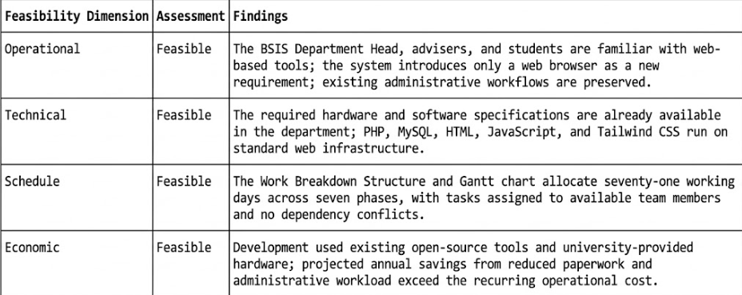
Operational Feasibility
Operational feasibility determines whether the system will be accepted and used by its intended end-users. Interviews and consultations with the BSIS Department Head, faculty capstone advisers, and student groups revealed that manual capstone monitoring, particularly tracking chapter submissions through private email attachments, flash drives, and group chat threads, consumed a significant amount of administrative time and frequently resulted in missed deadlines. The Department Head explicitly endorsed a centralized monitoring system and confirmed the availability of faculty advisers and students to participate in the User Acceptance Testing. Because the CPMMIS requires no radical change in existing administrative procedures and introduces only a familiar web browser interface, it was assessed as operationally feasible.

Front End
HTML
HyperText Markup Language (HTML) is the main building block used to create the front end of the system. It handles the basic structure and layout of the web pages. For the CPMMIS, HTML5 makes it possible to move away from manual, paper-based capstone tracking and turn it into a clear online portal.
CSS
Cascading Style Sheets (CSS) is used to control the design of the system, including the fonts, colors, and how the layout looks on different screen sizes. This is important for the CPMMIS because it makes sure the BSIS Department Head and advisers can easily read and click through the dashboards and document files.
Tailwind CSS
Tailwind CSS is a framework that helps developers style web pages quickly without having to write long, complicated CSS files from scratch. This tool was used to speed up the design process of the CPMMIS interface. It made it easy to create the color-coded project health indicators and ensured the system looks good on any computer or tablet.
JavaScript
JavaScript was added to make the system more interactive. It powers features such as the admin-adviser messaging widget and the pop-up windows. It is also responsible for the system's automatic deadline tracking, allowing the 3-day "nudge" notifications to appear instantly on the screen without needing to refresh the page.

Back End
PHP
Hypertext Preprocessor (PHP) was selected as the primary server-side scripting language to automate the system's core business logic, including the adviser workload overview and the automated triggering of 3-day deadline alerts. By seamlessly linking the visual layer with robust back-end logic, PHP eliminates manual monitoring errors and ensures the consistent application of departmental workflows.
MySQL
MySQL was used to manage the storage and retrieval of student group profiles, submitted capstone iterations, adviser records, and messages within a centralized, relational repository. This directly addresses the problem of fragmented thesis data scattered across flash drives and private email attachments.
jQuery
jQuery, a lightweight JavaScript library, was utilized to simplify DOM traversal and manage asynchronous AJAX requests, keeping the system's dynamic interfaces consistently responsive. This is particularly crucial for the CPMMIS admin-adviser messaging widget and the live notification bell, where data must be fetched and displayed instantly without requiring full page reloads.
User Acceptance Survey
The developed web application entitled Capstone Project Monitoring and Management Information System (CPMMIS) will undergo rigorous user acceptance testing (UAT) by the intended end-users within the Carlos Hilado Memorial State University–Fortune Towne (CHMSU-FT) campus. This testing cohort specifically includes the BSIS Department Head, faculty capstone advisers, and active BSIS student groups.

Technical Feasibility
Hardware Specifications
Hardware | Requirement Specifications
Processor | 2.4 GHz and above
Memory | 4 Gigabytes
Storage | 240 Gigabytes and above
Network | 25 Mbps and above
Table 2. Minimum Hardware Requirement
Software Specifications
Software | Requirement Specifications
Operating System | Linux, Mac Os X, Windows 7, 8, 10, 11
Browser | Google Chrome, Microsoft Edge, Mozilla Firefox
Table 3. Minimum Software Requirement

System Architecture
The system architecture design, shown in Figure 3, depicts the overall functionality of the system in terms of how various users interact with it. The diagram demonstrates how the web-based system will be hosted online, allowing users such as Faculty (Advisers), Student Groups, and Administrators to access it through a computer, laptop, or mobile device via an internet connection.
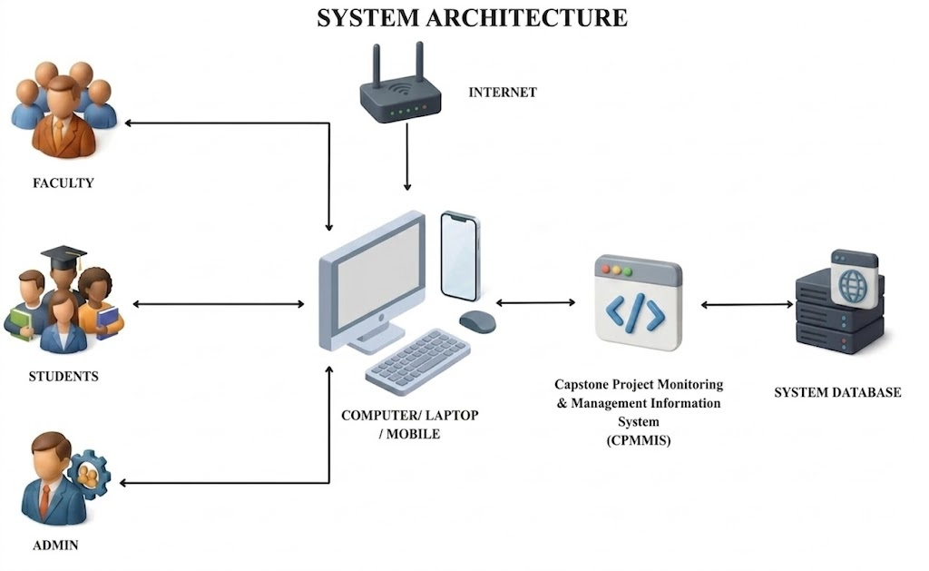
Figure 3. Architectural Framework

Schedule Feasibility
Work breakdown Structure
A Schedule Feasibility assessment evaluates whether the project timeline is realistic given the available resources, technical dependencies, and team capacity. It breaks down the Capstone Project Monitoring & Management Information System (CPMMIS) into sequential phases, each with clearly defined deliverables, resource requirements, and time allocations. At the lowest level, every task is tied to a specific DFD process and data store to ensure full system coverage. This structure helps the development team track progress against milestones and confirms that all 11 functional processes can be completed within the allotted timeframe.
ACTIVITY | ASSIGNED TO | PLAN START | PLAN DURATION | START DATE | END DATE | ACTUAL START | ACTUAL DURATION | PERCENT COMPLETE
1. PLAN | All | 1 | 15 | 3/2/2026 | 3/20/2026 | 1 | 15 | 100%
1.1 DOCUMENT ANALYSIS | All | 2 | 3 | 3/2/2026 | 3/4/2026 | 2 | 3 | 100%
1.2 DATA GATHERING | All | 5 | 3 | 3/5/2026 | 3/9/2026 | 5 | 3 | 100%
1.3 ANALYSIS OF PROCESS | All | 10 | 3 | 3/10/2026 | 3/12/2026 | 10 | 3 | 100%
1.4 CONDUCT RRL | John Rainer Tacutan | 12 | 2 | 3/13/2026 | 3/14/2026 | 12 | 2 | 100%
1.5 DEFINE OBJECTIVES OF THE STUDY | John Patrick Tejoc | 16 | 1 | 3/16/2026 | 3/16/2026 | 16 | 1 | 100%
1.6 SCOPE AND LIMITATION | John Patrick Tejoc | 17 | 1 | 3/17/2026 | 3/17/2026 | 17 | 1 | 100%
1.7 GANTT CHART PREPARATION | John Patrick Tejoc | 18 | 1 | 3/18/2026 | 3/18/2026 | 18 | 1 | 100%
1.8 FEASIBILITY ASSESSMENT | John Rainer Tacutan | 19 | 1 | 3/19/2026 | 3/19/2026 | 19 | 1 | 100%
2. DESIGN | All | 20 | 11 | 3/20/2026 | 4/1/2026 | 20 | 11 | 100%
2.1 SIDE MODEL | Rheza Mae Loqueloque | 20 | 2 | 3/20/2026 | 3/21/2026 | 20 | 2 | 100%
2.2 SYSTEM ARCHITECTURE | John Rainer Tacutan | 23 | 1 | 3/24/2026 | 3/24/2026 | 23 | 1 | 100%
2.3 ENTITY RELATIONSHIP DIAGRAM (ERD) | Rheza Mae Loqueloque | 24 | 2 | 3/25/2026 | 3/26/2026 | 24 | 2 | 100%
2.4 DATA FLOW DIAGRAM (DFD) | Jhelian Coberos | 26 | 3 | 3/27/2026 | 3/29/2026 | 26 | 3 | 100%
2.5 UI DESIGN | John Patrick Tejoc | 30 | 2 | 3/31/2026 | 4/1/2026 | 30 | 2 | 100%
3. DEVELOP | All | 32 | 22 | 4/2/2026 | 5/1/2026 | 32 | 22 | 50%
3.1 FRONT-END DEVELOPMENT | John Patrick Tejoc | 32 | 4 | 4/2/2026 | 4/6/2026 | 32 | 4 | 50%
3.2 BACK-END DEVELOPMENT | John Patrick Tejoc | 37 | 4 | 4/7/2026 | 4/10/2026 | 37 | 4 | 50%
3.3 MODULE CODING | John Patrick Tejoc | 41 | 14 | 4/11/2026 | 4/25/2026 | 41 | 14 | 50%
3.4 REVIEW AND REFINEMENT | All | 53 | 4 | 4/27/2026 | 5/1/2026 | 53 | 4 | 50%
Figure 4. Gantt chart
Cost Benefits Analysis
Cost-benefit analysis (CBA) is a framework for evaluating a project by weighing its monetary costs against its monetary benefits to determine whether the benefits justify the expenses. Figures 5 and 6 detail the financial assessment of the system.
Figure 5 itemizes the upfront development expenditures and continuing annual operational costs, paired with the projected savings from minimized paperwork, reduced administrative workload, and enhanced resource allocation. Figure 5 itemizes the upfront development expenditures and continuing annual operational costs, paired with the projected savings from minimized paperwork, reduced administrative workload, and enhanced resource allocation. Figure 6 shows the long-term financial projections, presenting the system's estimated net present value (NPV), return on investment (ROI), and precise payback period.
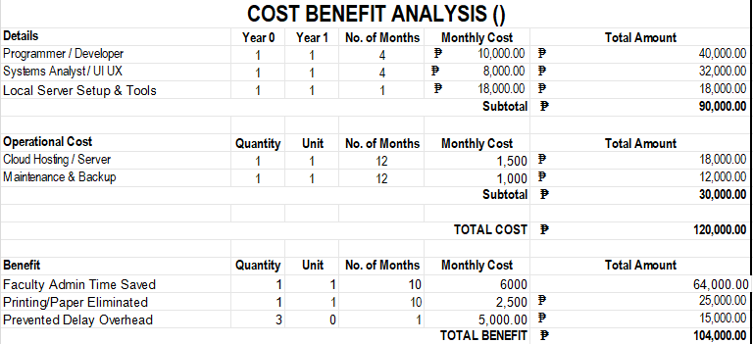
Figure 5. Cost Breakdown
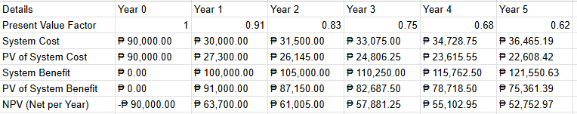
Total PV of System Cost: ₱ 214,475.22
Total PV of System Benefit: ₱ 414,917.39
Total NPV: ₱ 200,442.17
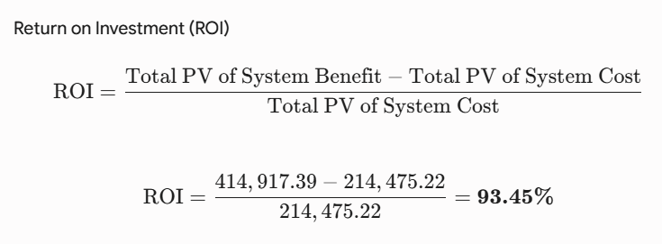

ERD Model
The ERD shows 14 linked database tables, highlighting relationships such as one-to-many between advisers and groups, along with functionalities for submissions, tasks, notifications, logs, and communication, facilitating effective management of capstone projects.
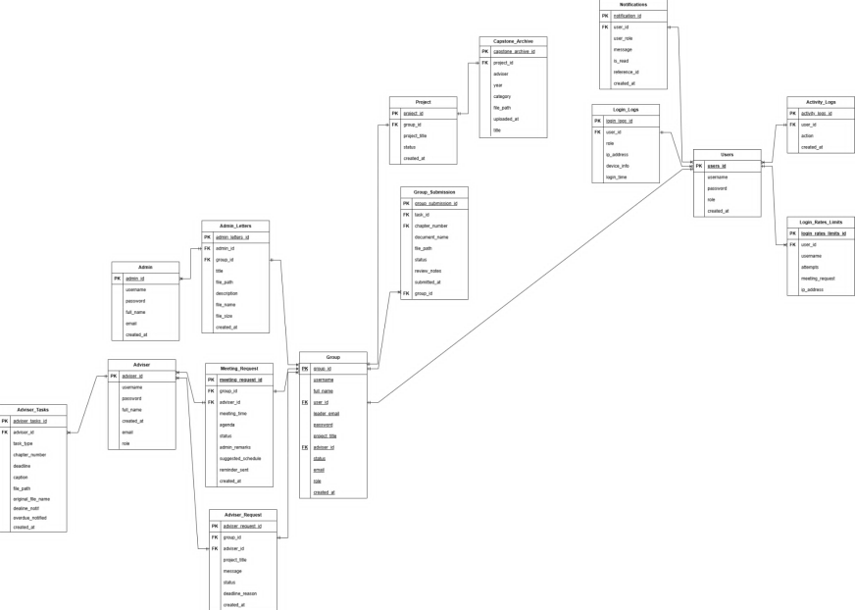
Figure 7. Entity Relationship Diagram

Data Flow Diagram
Figure 8 shows the Context Diagram of the system, which illustrates the high-level interactions between the platform and its external users. The central process, the Capstone Project Management and Monitoring Information System, acts as the core hub. The external entities — the Administrators, the Advisers, and the Student Groups — input data such as group approvals, adviser assignments, task postings, chapter submissions, meeting schedules, and feedback into the system. In return, they receive processed outputs like automated deadline reminders, submission review results, digital letters, health status reports, archived capstone access, and real-time notifications.
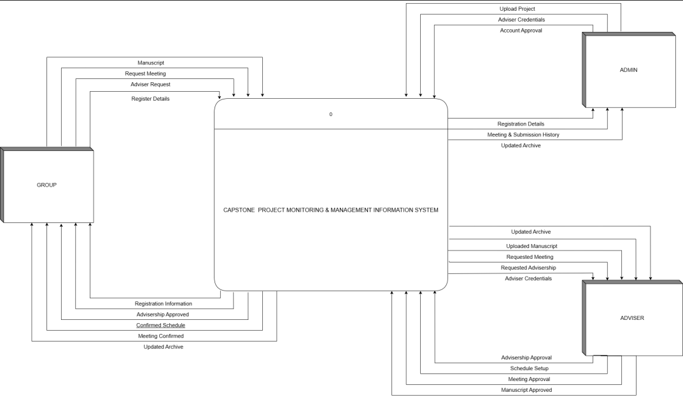
Figure 8. Context Diagram
Figure 9 presents the Data Flow Diagram (DFD), detailing how information moves through the system's internal processes. It maps out the step-by-step data pathways, starting from user authentication and group registration, moving through adviser assignment and task management, and concluding with the generation of health status reports, notifications, and archived capstone records. This diagram outlines exactly where data originates, how it is transformed by the backend PHP logic, and where it is permanently stored within the database.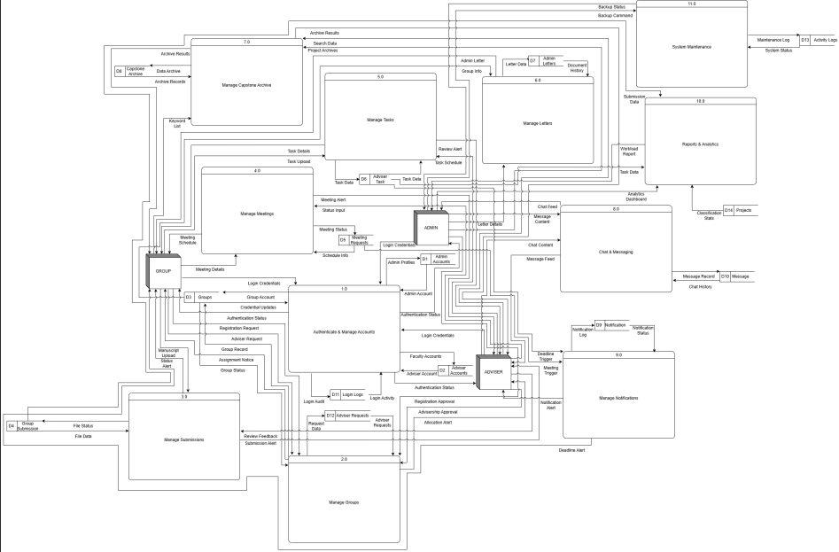

Data Dictionary
TABLE: admin
Field Name | Data Type | NULL | KEY | Description
Admin_id | Int (11) | No | PK | Unique administrator identifier
Username | Varchar(50) | No | UNI | Admin login username
Password | Varchar(255) | No |  | Bcrypt-hashed password
Full name | Varchar(100) | Yes |  | Admin full name
Email | Varchar(100) | Yes |  | Admin email address
Created_at | Timesptamp | No |  | Account creation timestamp

TABLE: adviser
Field Name | Data Type | NULL | KEY | Description
Adviser_id | Int (11) | No | PK | Unique adviser identifier
Username | Varchar(50) | No | UNI | Adviser login username
Password | Varchar(255) | No |  | Bcrypt-hashed password
Full name | Varchar(100) | Yes |  | Adviser full name
Email | Varchar(100) | Yes |  | Adviser email address
Role | Enum('adviser','admin') | No |  | User role (default 'adviser')
created_at | Timesptamp | No |  | Account creation timestamp

TABLE: Group
Field Name | Data Type | NULL | KEY | Description
Group_id | Int | No | PK | Unique group identifier
Username | Varchar(50) | No | UNI | Group login username
Full_name | Varchar(255) | Yes |  | Group/leader display name
Leader_email | Varchar(255) | No |  | Group leader's email
Password | Varchar(255) | No |  | Bcrypt-hashed password
Project_title | Varchar(255) | No |  | Capstone project title (default 'Untitled Project')
Email | Varchar(100) | Yes |  | Alternate email
Adviser_id | Int(11) | Yes | FK | Assigned faculty adviser (ON DELETE SET NULL)
Role | Varchar(10) | No |  | User role (default 'student')
Created_at | Timestamp | No |  | Account creation timestamp
Status | Varchar(20) | No |  | Account status (default 'pending')

TABLE: adviser_requests
Field Name | Data Type | NULL | KEY | Description
Adviser_request_id | Int(11) | No | PK | Unique request identifier
Group_id | Int(11) | Yes | FK | Requesting group
Adviseer_id | Int(11) | Yes | FK | Target adviser
Project_title | Varchar(255) | Yes |  | Project title at time of request
Message | Text | Yes |  | Accompanying message from group
Status | Enum('pending','accepted','declined') | No |  | Request status (default 'pending')
Decline _reason | Text | Yes |  | Reason if adviser declined
Created_at | Timestamp | No |  | Request submission timestamp

TABLE: group_submission
Field Name | Data Type | NULL | KEY | Description
Group_submission_id | Int(11) | No | PRI | Unique submission identifier
Group_id | Int (11) | No | FK | Submitting group (ON DELETE CASCADE)
Chapter_number | Int(1) | No |  | Chapter number (1-5)
Document_name | Varchar(255) | No |  | Display name of document
File_ path | Varchar(255) | No |  | Server path to uploaded file
Version | Int(11) | No |  | Version number (default 1)
Is_final | Tinyint (1) | No |  | Whether this is the final submission (default 0)
Task_id | Int(11) | Yes |  | Links to adviser_tasks.id
Status | Enum('pending','approved','rejected') | No |  | Review status (default 'pending')
Review_notes | Text | Yes |  | Adviser/Admin feedback
Created_at | timestamp | No |  | Submission timestamp

TABLE: meeting_requests
Field Name | Data Type | NULL | KEY | Description
Meeting_request_id | Int(11) | No | PRI | Unique meeting identifier
group_id | Int(11) | No |  | Requesting group
adviser_id | Int(11) | No |  | Invited adviser
meeting_time | Datetime | No |  | Proposed meeting date/time
agenda | text | No |  | Meeting topics
status | Enum('pending','accepted','declined') | No |  | Meeting status (default 'pending')
admin_remarks | Text | Yes |  | Admin notes on the meeting
suggested_reschedule | Datetime | Yes |  | Alternative time if declined
reminder_sent | Tinyint(1) | No |  | Whether reminder notification was sent (default 0)
created_at | Timestamp | No |  | Request creation timestamp

TABLE: notifications
Field Name | Data Type | NULL | KEY | Description
notification_id | Int(11) | No | PK | Unique notification identifier
user_id | Int(11) | No |  | Recipient user ID
User_role | enum('admin','adviser','group') | No |  | Recipient role
message | text | No |  | Notification body text
Is_read | Tinyint(1) | No |  | Read status (default 0 = unread)
Reference_id | Int(11) | Yes |  | Related record ID for context
Group_id | Int(11) | Yes |  | Related group ID
created_at | timestamp | No |  | Notification timestamp

TABLE: login_logs
Field Name | Data Type | NULL | KEY | Description
Login_logs_id | Int (11) | No | PK | Unique log identifier
user_id | Int(11) | No |  | ID of the user who logged in
role | Varchar(20) | No |  | User role at time of login
ip_address | varchar(45) | Yes |  | Client IP address (supports IPv6)
Device_info | varchar(255) | Yes |  | Browser/device user-agent string
Login_time | Int(11) | No |  | Login event timestamp

TABLE: activity_logs
Field Name | Data Type | NULL | KEY | Description
activity_logs_id | Int (11) | No | PK | Unique activity identifier
user_id | Int(11) | No |  | ID of user who performed the action
action | Varchar(255) | No |  | Description of the action performed
Created_at | timestamp | No |  | Activity timestamp

TABLE: projects
Field Name | Data Type | NULL | KEY | Description
Project_id | Int (11) | No | PK | Unique project identifier
group_id | Int(11) | No | FK | Owning group (ON DELETE CASCADE)
Project_title | text | No |  | Full project title
Status | enum('pending','approved','rejected') | No |  | Project approval status (default 'pending')
Created_at | timestamp | No |  | Registry creation timestamp

TABLE: users
Field Name | Data Type | NULL | KEY | Description
user_id | Int (11) | No | PK | Unique user identifier
Username | Varchar(50) | No | UNI | Legacy login username
Password | Varchar(255) | No |  | Legacy password hash
Role | enum('admin','faculty','student') | No |  | Legacy role (default 'student')
Created_at | timestamp | No |  | Account creation timestamp

TABLE: capstone_archive
Field Name | Data Type | NULL | KEY | Description
Capstone_archive_id | Int (11) | No | PK | Unique archive identifier
title | Varchar(255) | No | UNI | Capstone project title
Adviser | varchar(100) | yes |  | Adviser name
Year | Varchar(10) | Yes |  | Year completed
Category | Varchar(50) | No |  | Project category (default 'Standard')
File_path | Varchar(255) | Yes |  | Server path to archived document
Uploaded_at | timestamp | No |  | Archive upload timestamp

TABLE: admin_letters
Field Name | Data Type | NULL | KEY | Description
Admin_letter_id | Int (11) | No | PK | Unique letter identifier
Group_id | Int(11) | No | INDEX | Recipient group
Admin_id | Int(11) | No | INDEX | Sending administrator
title | varchar(255) | No |  | Letter/document title
description | text | Yes |  | Optional description
File_path | varchar(255) | No |  | Server file path
File_name | varchar(255) | No |  | Original filename
File_size | Int(11) | Yes |  | File size in bytes
Created_at | timestamp | No |  | Upload timestamp

TABLE: adviser_tasks
Field Name | Data Type | NULL | KEY | Description
Adviser_task_id | Int (11) | No | PK | Unique task identifier
adviser_id | Int(11) | No |  | Assigning adviser
chapter_number | Int(1) | Yes |  | Chapter number 1-5
Deadline | datetime | No |  | Submission deadline
File_path | varchar(255) | Yes |  | Reference file path
Original_filename | varchar(255) | Yes |  | Reference file original name
deadline_notified | Tinyint(1) | No |  | Whether deadline reminder sent (default 0)
overdue_notified | tinyint(1) | No |  | Whether overdue notice sent (default 0)
Created_at | timestamp | No |  | Task creation timestamp

TABLE: messages
Field Name | Data Type | NULL | KEY | Description
message_id | Int (11) | No | PK | Unique message identifier
Sender_id | Int(11) | No |  | Sender user ID
Sender_role | enum('admin','adviser') | No |  | Sender role
Receiver_id | Int(11) | No |  | Receiver user ID
Receiver_role | enum('admin','adviser') | No |  | Receiver role
message | text | No |  | Message content
Is_read | tinyint(1) | No |  | Read status (default 0 = unread)
Created_at | timestamp | No |  | Message timestamp

References
Ben Kasmia, N., & M'hamed, H. (2023). Digitalization of higher education: Impacts on management practices and institutional development. Conhecimento & Diversidade, 15(39), 56–82. https://doi.org/10.18316/rcd.v15i39.11135
De Vreugd, L. B., Van Leeuwen, A., Jansen, R. S., & Van Der Schaaf, M. F. (2024). Learning analytics dashboard design and evaluation to support student self-regulation of study behaviour. Journal of Learning Analytics, 11(3), 249–262. https://doi.org/10.18608/jla.2024.8529
Fachrizal, M. R., Wibawa, J. C., & Afifah, Z. (2020). Web-based project management information system in construction projects. IOP Conference Series: Materials Science and Engineering, 879, 012064. https://doi.org/10.1088/1757-899X/879/1/012064
Laudon, K. C., & Laudon, J. P. (2021). Management Information Systems: Managing the Digital Firm (17th ed.). Pearson.
Lukins, S. (2024, August 29). What is a capstone project? And why is it important? TopUniversities. https://www.topuniversities.com/student-info/careers-advice/what-capstone-project-why-it-important
Pallomina, K. C. A. J. M., & Brosas, D. G. (2025). Integrating skills competency assessment and academic performance for career pathway mapping in analytics and AI. 2025 Eight International Conference on Vocational Education and Electrical Engineering (ICVEE), 15–19. https://doi.org/10.1109/ICVEE66651.2025.11281407
Perante, W. J. A., Barnaba Jr., E. O., Cañete, J. R., & Niegas, M. E. (2024). Design and develop a thesis and capstone project manuscript archiving management system for Eastern Visayas State University Ormoc Campus. ResearchGate. https://doi.org/10.13140/RG.2.2.27704.28168
Pressman, R. S., & Maxim, B. R. (2020). Software Engineering: A Practitioner's Approach (9th ed.). McGraw-Hill.
Sankar, S., Ramkumar, A. P., Pandipati, P., & Manish, A. (2023). Student management system (Capstone project). Vellore Institute of Technology.
Secreto, P. V., Ofrin, D., & Tabo, E. (2025). Data-driven decision-making through real-time student progress monitoring: Academic administrators perspectives. International Journal in Information Technology in Governance, Education and Business, 7(1). https://doi.org/10.32664/ijitgeb.v7i1.147
Singun, A. J. (2025). Unveiling the barriers to digital transformation in higher education institutions: A systematic literature review. Discover Education, 4, 37. https://doi.org/10.1007/s44217-025-00437-2
SourceCodester. (2021). Online thesis archiving system using PHP/OOP with free source code. https://www.sourcecodester.com/php/15083/online-thesis-archiving-system-using-phpoop-free-source-code.html

Feasibility Schedule
Work Breakdown Structure
The feasibility schedule outlines the estimated timeline followed by the researchers during the development of the Capstone Project Monitoring and Management Information System (CPMMIS). The project was divided into manageable phases to ensure timely completion and organized workflow. Each activity was scheduled based on the Agile Software Development Life Cycle, allowing continuous development and feedback throughout the project.
TABLE 4. Feasibility schedule
ACTIVITY | ASSIGNED TO | PLAN START | PLAN DURATION | START DATE | END DATE | ACTUAL START | ACTUAL DURATION | PERCENT COMPLETE
1. PLAN | All | 1 | 15 | 3/2/2026 | 3/20/2026 | 1 | 15 | 100%
1.1 DOCUMENT ANALYSIS | All | 2 | 3 | 3/2/2026 | 3/5/2026 | 2 | 3 | 100%
1.2 DATA GATHERING | All | 5 | 3 | 3/6/2026 | 3/11/2026 | 5 | 3 | 100%
1.3 ANALYSIS OF PROCESS | All | 10 | 3 | 3/11/2026 | 3/13/2026 | 10 | 3 | 100%
1.4 CONDUCT RRL | John Rainer Tacutan | 12 | 2 | 3/13/2026 | 3/15/2026 | 12 | 2 | 100%
1.5 DEFINE OBJECTIVES OF THE STUDY | John Patrick Tejoc | 16 | 1 | 3/17/2026 | 3/17/2026 | 16 | 1 | 100%
1.6 SCOPE AND LIMITATION | John Patrick Tejoc | 17 | 1 | 3/18/2026 | 3/18/2026 | 17 | 1 | 100%
1.7 GANTT CHART PREPARATION | John Patrick Tejoc | 18 | 1 | 3/19/2026 | 3/19/2026 | 18 | 1 | 100%
1.8 FEASIBILITY ASSESSMENT | John Rainer Tacutan | 19 | 1 | 3/20/2026 | 3/20/2026 | 19 | 1 | 100%
2. DESIGN | All | 20 | 8 | 3/21/2026 | 4/1/2026 | 20 | 8 | 100%
2.1 SIDE MODEL | Rheza Mae Loqueloque | 20 | 1 | 3/21/2026 | 3/22/2026 | 20 | 1 | 100%
2.2 SYSTEM ARCHITECTURE | John Rainer Tacutan | 23 | 1 | 3/24/2026 | 3/24/2026 | 23 | 1 | 100%
2.3 ENTITY RELATIONSHIP DIAGRAM (ERD) | Rheza Mae Loqueloque | 24 | 2 | 3/25/2026 | 3/26/2026 | 24 | 2 | 100%
2.4 DATA FLOW DIAGRAM (DFD) | Jhelian Coberos | 26 | 2 | 3/27/2026 | 3/29/2026 | 26 | 2 | 100%
2.5 UI DESIGN | John Patrick Tejoc | 30 | 2 | 4/1/2026 | 4/1/2026 | 30 | 2 | 100%
3. DEVELOP | All | 32 | 22 | 4/2/2026 | 5/1/2026 | 32 | 22 | 100%
3.1 FRONT-END DEVELOPMENT | John Patrick Tejoc | 32 | 3 | 4/2/2026 | 4/6/2026 | 32 | 3 | 50%
3.2 BACK-END DEVELOPMENT | John Patrick Tejoc | 37 | 4 | 4/7/2026 | 4/10/2026 | 37 | 4 | 50%
3.3 MODULE CODING | John Patrick Tejoc | 41 | 12 | 4/11/2026 | 4/29/2026 | 41 | 12 | 50%
3.4 REVIEW AND REFINEMENT | All | 53 | 1 | 4/29/2026 | 5/1/2026 | 53 | 1 | 50%
4. TEST | All | 54 | 8 | 5/2/2026 | 5/10/2026 | 54 | 8 | 100%
4.1 UNIT TESTING | All | 54 | 2 | 5/3/2026 | 5/3/2026 | 54 | 2 | 100%
4.2 INTEGRATION TESTING | All | 56 | 2 | 5/4/2026 | 5/5/2026 | 56 | 2 | 100%
4.3 USER ACCEPTANCE TESTING | All | 58 | 2 | 5/6/2026 | 5/7/2026 | 58 | 2 | 100%
4.4 BUG FIXING AND DEBUGGING | All | 60 | 4 | 5/8/2026 | 5/10/2026 | 60 | 4 | 100%
5. DEPLOY | All | 63 | 4 | 5/11/2026 | 5/15/2026 | 63 | 4 | 100%
5.1 SYSTEM DEPLOYMENT | All | 63 | 2 | 5/11/2026 | 5/12/2026 | 63 | 2 | 100%
5.2 DOCUMENTATION | All | 65 | 1 | 5/13/2026 | 5/13/2026 | 65 | 1 | 100%
5.3 FINAL PRESENTATION | All | 66 | 1 | 5/14/2026 | 5/15/2026 | 66 | 1 | 100%

Work Breakdown Structure
The work breakdown structure presents the major tasks involved in the development of CPMMIS.
Planning Phase
- Topic selection
- Proposal preparation
- Adviser consultation
- Requirement gathering
Design Phase
- UI/UX design
- Database design
- ERD creation
- DFD creation
Development Phase
- Login and authentication module
- Student group management module
- Adviser management module
- Capstone submission module
- Dashboard and analysis module
- Notification module
- Chat integration module
Testing Phase
- Unit testing
- Integration testing
- User acceptance testing
- Bug fixing
Deployment Phase
- Final deployment
- User orientation
- Documentation Turnover

Cost Benefit Analysis
Estimated Development Cost
Item Estimated Cost
Internet Allowance ₱500
Laptop/Computer Usage ₱200
Hosting and Domain ₱500
Printing and Documentation ₱100
Miscellaneous Expenses ₱500
TOTAL ₱1,800

Expected Benefits
- Faster monitoring of student capstone progress
- Reduced paperwork and manual checking
- Organized file storage and digital archiving
- Better communication between advisers and students
- Real-time monitoring for administrators
- Reduced delays in capstone submissions
- Improved faculty workload distribution

Data Dictionary

Field Name | Description | Data Type | Length | Example
user_id | Unique identifier of the user | Integer | 11 | 1001
full_name | Complete name of the user | Varchar | 100 | Juan Dela Cruz
email | User email address | Varchar | 100 | juan@gmail.com
password | Encrypted user password | Varchar | 255 | ********
role | User role in the system | Varchar | 20 | Admin
adviser_id | Unique ID of adviser | Integer | 11 | 2001
group_id | Unique ID of student group | Integer | 11 | 3001
group_name | Name of capstone group | Varchar | 100 | BSIS Innovators
project_title | Title of capstone project | Varchar | 150 | CPMMIS
chapter_file | Uploaded project document | Varchar | 255 | chapter1.pdf
submission_date | Date of file submission | Date | — | 2026-05-29
deadline | Scheduled submission deadline | Date | — | 2026-06-01
project_status | Current project condition | Varchar | 20 | Green
notification_id | Unique notification ID | Integer | 11 | 4001
notification_message | Content of notification | Text | — | Deadline Reminder
meeting_id | Unique meeting record ID | Integer | 11 | 5001
meeting_date | Schedule of consultation | Date | — | 2026-05-30
feedback | Adviser comments and suggestions | Text | — | Revise Chapter 2
chat_message | Message sent in chat module | Text | — | Good morning
workload_count | Number of assigned groups per adviser | Integer | 5 | 4
archive_id | Unique archive record ID | Integer | 11 | 6001
uploaded_by | User who uploaded the file | Varchar | 100 | BSIS 3-D
file_version | Version number of submitted file | Varchar | 20 | Version 2

